TEST 1
SECTION 1
Questions 1 – 10
Complete the notes below.
Write ONE WORD AND/OR A NUMBER for each answer.
HIRING A PUBLIC ROOM
Example
● the Main Hall – seats ……….200……….
Room and cost
● the 1………….. Room – seats 100
● Cost of Main Hall for Saturday evening: 2 £……………
+ £250 deposit (3…………… payment is required)
● Cost includes use of tables and chairs and also 4……………..
● Additional charge for use of the kitchen: £25
Before the event
● Will need a 5……………. licence
● Need to contact caretaker (Mr Evans) in advance to arrange 6…………….
During the event
● The building is no smoking
● The band should use the 7…………….. door at the back
● Don’t touch the system that controls the volume
● For microphones, contact the caretaker
After the event
● Need to know the 8……………. for the cleaning cupboard
● The 9…………….. must be washed and rubbish placed in black bags
● All 10……………. Must be taken down
● Chairs and tables must be piled up

SECTION 2
Questions 11 – 14
Complete the notes below.
Write ONE WORD for each answer.
Fiddy Working Heritage Farm
Advice about visiting the farm
Visitors should
● take care not to harm any 11……………..
● not touch any 12…………….
● wear 13…………….
● not bring 14……………. into the farm, with certain exceptions.
Questions 15-20
Label the map below.
Write the correct letter A-I, next to Questions 15-20.
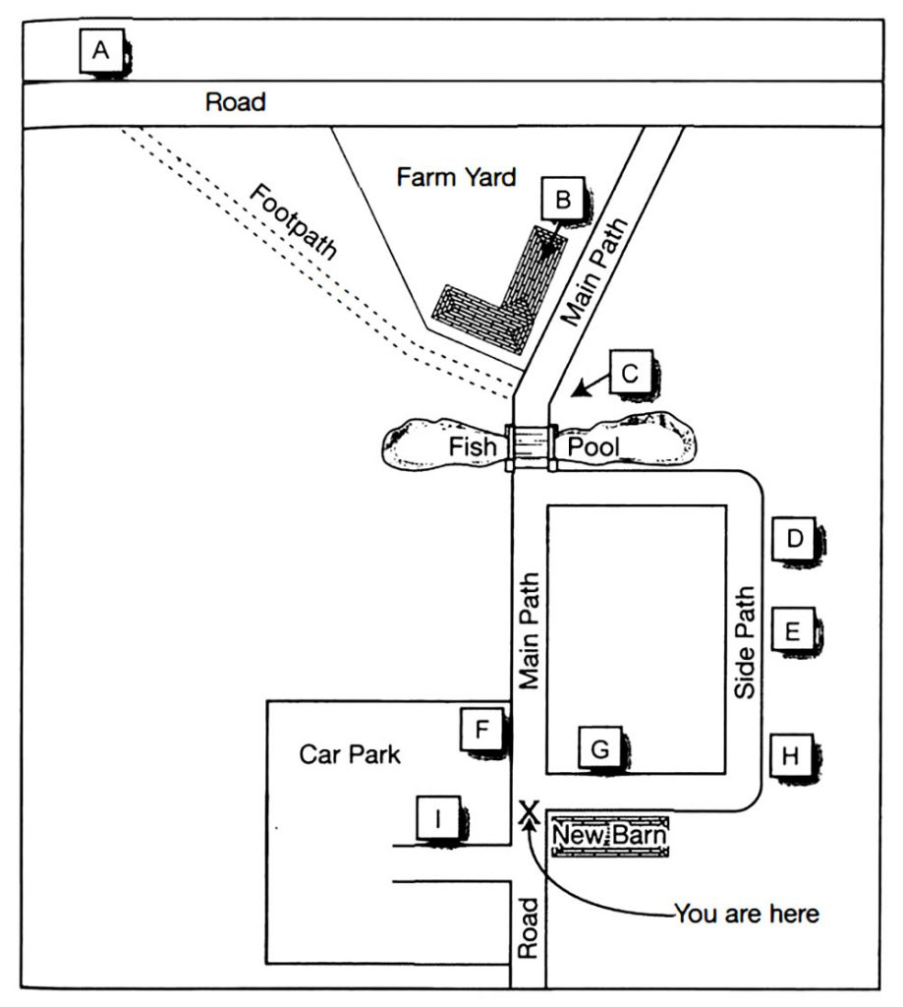
15 Scarecrow …………..
16 Maze …………..
17 Café …………..
18 Black Barn …………..
19 Covered picnic area …………..
20 Fiddy House …………..
SECTION 3
Questions 21 – 30
Choose the correct letter, A, B or C.
Study on Gender in Physics

21 The students in Akira Miyake’s study were all majoring in
A physics.
B psychology or physics.
C science, technology, engineering or mathematics.

22 The aim of Miyake’s study was to investigate
A what kind of women choose to study physics.
B a way of improving women’s performance in physics.
C whether fewer women than men study physics at college.

23 The female physics students were wrong to believe that
A the teachers marked them in an unfair way.
B the male students expected them to do badly.
C their test results were lower than the male students’.

24 Miyake’s team asked the students to write about
A what they enjoyed about studying physics.
B the successful experiences of other people.
C something that was important to them personally.

25 What was the aim of the writing exercise done by the subjects?
A to reduce stress
B to strengthen verbal ability
C to encourage logical thinking

26 What surprised the researchers about the study?
A how few students managed to get A grades
B the positive impact it had on physics results for women
C the difference between male and female performance

27 Greg and Lisa think Miyake’s results could have been affected by
A the length of the writing task.
B the number of students who took part.
C the information the students were given.

28 Greg and Lisa decide that in their own project, they will compare the effects of
A two different writing tasks.
B a writing task with an oral task.
C two different oral tasks.

29 The main finding of Smolinsky’s research was that class teamwork activities
A were most effective when done by all-women groups.
B had no effect on the performance of men or women.
C improved the results of men more than of women.

30 What will Lisa and Greg do next?
A talk to a professor
B observe a science class
C look at the science timetable

SECTION 4
Questions 31 – 40
Complete the notes below.
Write ONE WORD ONLY for each answer.
Ocean Biodiversity
Biodiversity hotspots
● areas containing many different species
● important for locating targets for 31……………
● at first only identified on land
Boris Worm, 2005
● identified hotspots for large ocean predators, e.g. sharks
● found the ocean hotspots:
– were not always rich in 32………………
– had higher temperatures at the 33……………..
– had sufficient 34…………….. in the water
Lisa Ballance, 2007
● looked for hotspots for marine 35……………..
● found these were all located where ocean currents meet
Census of Marine Life
● found new ocean species living:
– under the 36………………
– near volcanoes on the ocean floor
Global Marine Species Assessment
● want to list endangered ocean species, considering:
– population size
– geographical distribution
– rate of 37……………….
● Aim: to assess 20,000 species and make a distribution 38………………. for each one
Recommendations to retain ocean biodiversity
● increase the number of ocean reserves
● establish 39……………… corridors (e.g. for turtles)
● reduce fishing quotas
● catch fish only for the purpose of 40……………..

